1. A paragraph on what PaaS, SaaS and IaaS are and the differences between them.
   * <https://www.bigcommerce.com/blog/saas-vs-paas-vs-iaas/#the-key-differences-between-on-premise-saas-paas-iaas>
   * <https://www.red74tech.com/advice/iaas-saas-paas-naas-different-flavors-of-cloud-services/>
   * <https://apprenda.com/library/paas/iaas-paas-saas-explained-compared/>

Answer：

Three of them are on-cloud computing over the internet, which compared with them is on-premise computing.

PaaS：Platform as a Service, providing developers with a framework, software and tools needed to build apps and software, which could be accessed by multiple users, easy to run without sophisticated system administration knowledge. Cons: hard to integrate, security, not fully optimized for language and framework your business uses, scarify the runtime, operational limitations.

SaaS：Software as a Service, ready to use and run from a user’s web browser, hosted on a remote server. Cons: Security, interoperability, minimal customization for features, capabilities and integrations, lack of control of data/functionality/performance.

IaaS：Infrastructure as a Service, physical infrastructure, allowing business to purchase resources flexibly on-demand instead of maintaining on-premise IT infrastructure hardware which is costly and labor-intensive. Cons: upgraded or replaced the older systems,osecurity, internal training for the updates.

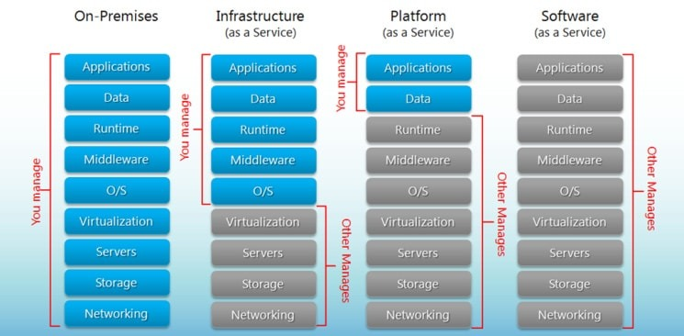

1. A paragraph on the differences between ETL and ELT. Also, list the pros and cons of each in a chart.

|  |  |  |  |
| --- | --- | --- | --- |
|  | Definition | Pros | Cons |
| **ETL** | * Extract, Transformation, Load Process for data * Moves from the data source to staging into the data warehouse | 1. Data privacy by cleansing sensitive and secure data(e.g. GDPR, HIPAA need to remove or encrypt sensitive data to protect the privacy of their clients) before loading into the data warehouse 2. Can perform sophisticated data transformations and more cost-effective, speedy analysis than ELT | 1. Aggregation becomes complicated when the datasets increases in size. 2. Physical server requires frequent maintenance. |
| **ELT** | * Extract, Load, Transformation Process for data * No data staging, leverage the data lakes to do basic transformations * Huge quantities of data, both structured and unstructured | 1. Flexible, save any type of data 2. High-speed; low maintenance(do not require special hardware); quicker loading | 1. Less reliable 2. The need to transform after loading slows down the total time it takes for querying/anlysis |